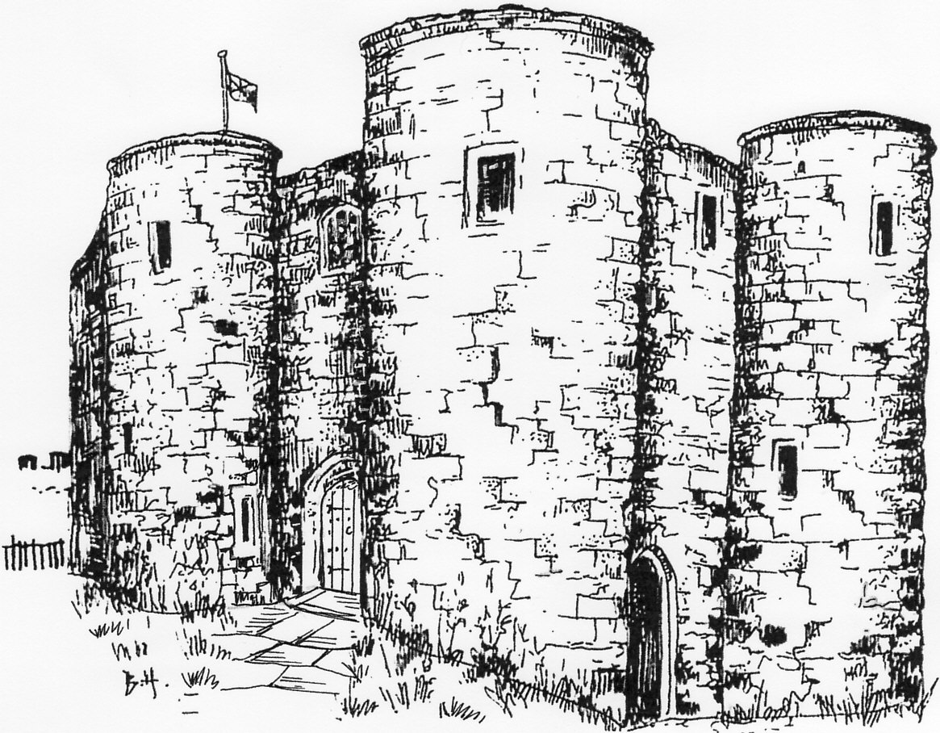Rye Castle Museum
Membership Form
You can contact us at any time to change or delete the information we hold about you. Our Privacy Policy is on our website www.ryemuseum.org.uk
Name
Name
Address and Postcode
Contact Telephone
Contact E-mail
Type of Membership -  Annual | Single Two People Same Address  Family (2 Adults, 2 Children)
Type of Membership -  Life | Single Two People Same Address
Donation | £
Contact Preferences | Post Email Phone
OR Please tick if you do not wish to be contacted.
Our Bank details for Bank Transfer or Standing Order | CAF Bank  Sort Code: 40-52-40  Account Number: 00008079  Account Name: Rye Museum Association  Please write your Surname and Initial in the Reference  Please make cheques payable to Rye Museum Association
Gift Aid Declaration | Gift Aid allows us to claim back a portion of tax you paid, at no additional cost to you. For every £1 you give us through your Membership, we can claim 25p in addition from HM Revenue and Customs at no extra cost to you.  Please read and sign the consent form below.  I confirm I have paid or will pay an amount of Income Tax and/or Capital Gains Tax for each tax year (6 April to 5 April) that is at least equal to the amount of tax that all the charities that I donate to will reclaim on my gifts for that tax year. I understand that other taxes such as VAT and Council Tax do not qualify. I understand the charity will reclaim 25p of tax on every £1 that I give on or after 6 April 2008.  Please notify us if you change your name, address or tax status. Cancellation of written declarations will only apply to donations received from the date of cancellation.

